台南市安順國中104學年度第一學期第一次定期考一年級英語科試題
命題教師：陳秀卿 審題教師：葉莉玲t
- 聽力測驗：(15%)

(一)辨識句意：根據聽到的內容，選出符合描述的圖片或符合圖片的描述。： 每題1分，共5分
- (Ａ) 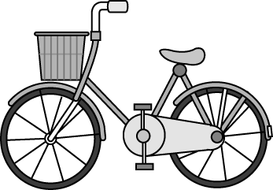(Ｂ) 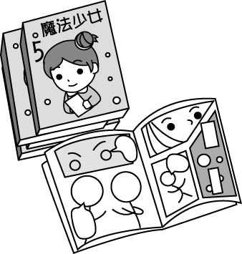(Ｃ) 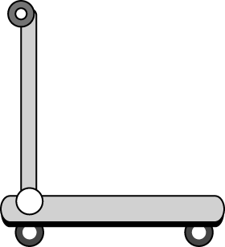

- (Ａ) 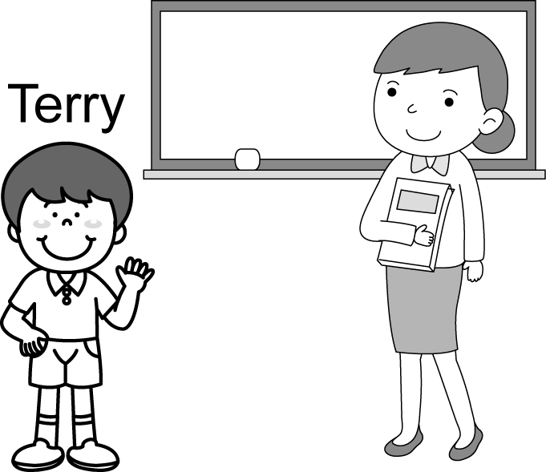 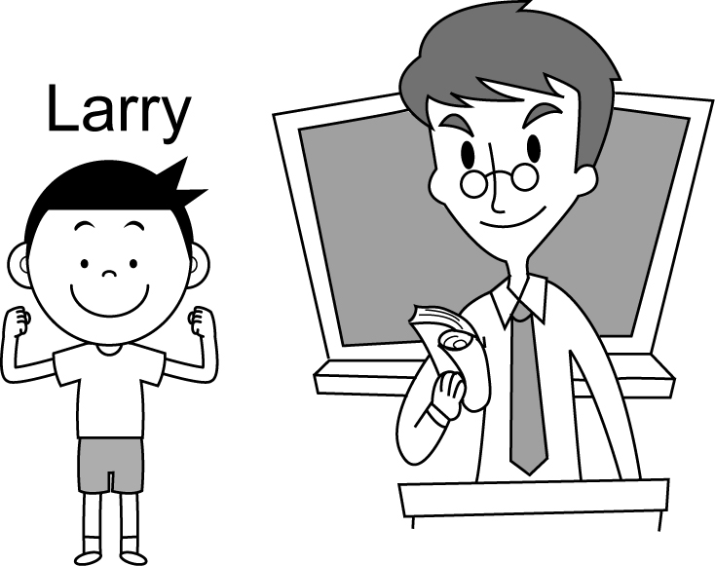 (Ｂ) 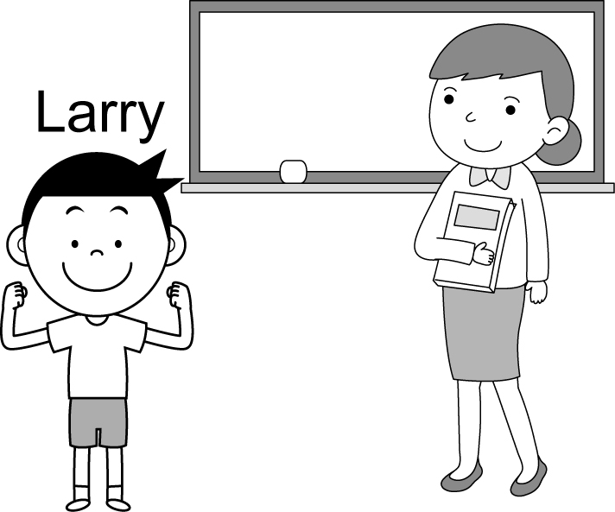
(Ｃ) 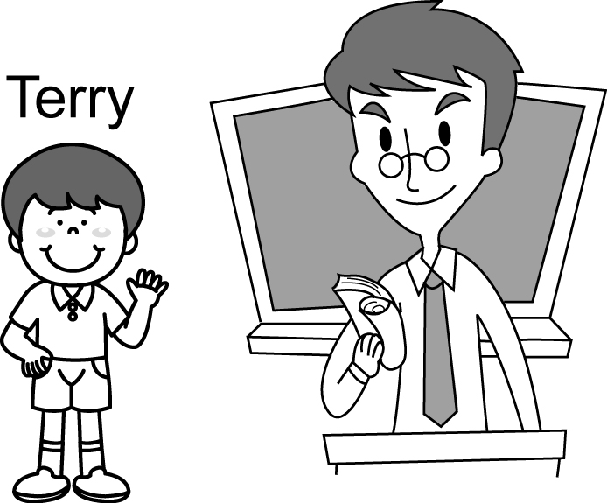

- (Ａ)  (Ｂ)  (Ｃ) 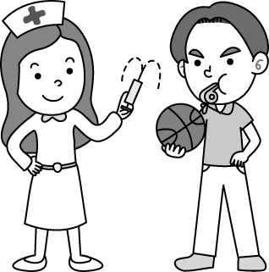

- (Ａ) 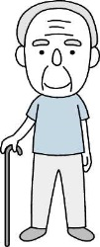 (Ｂ)  (Ｃ) 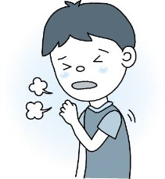

- (Ａ) 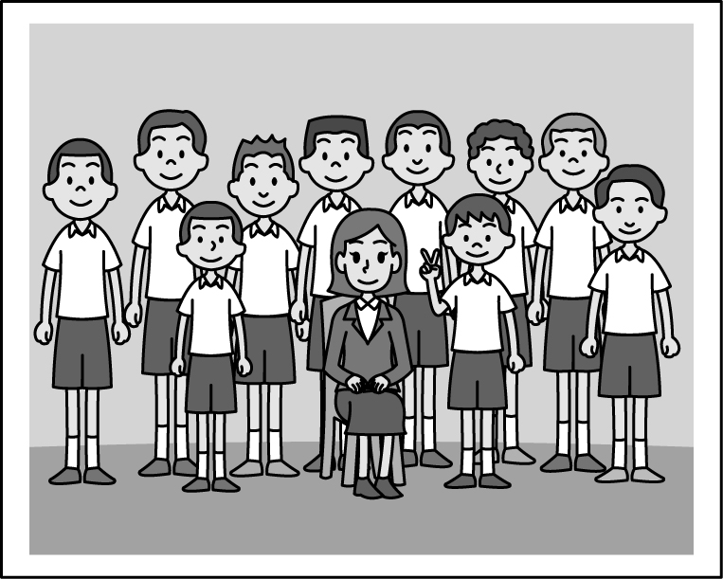(Ｂ) 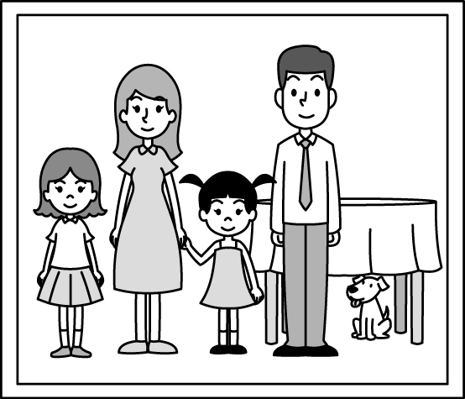 (Ｃ) 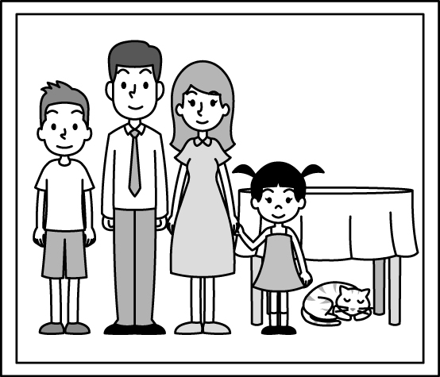

(二)基本問答：根據聽到的內容，選出一個最適合的回應或最適合的問句。：每題1分，共5分
- (Ａ) Not bad, thank you. (Ｂ) Ten. (Ｃ) Pretty and nice.
- (Ａ) Nice to meet you, too. My name is Terry.
(Ｂ) Yes, I’m your student. Nice to meet you, Nicole.
(Ｃ) Nice to meet you, Nicole. I’m not your teacher.
- (Ａ) I’m not in the class. (Ｂ) This is our classroom.
(Ｃ) Really? I’m in Class 709, too.
- (Ａ) Yes, Jeremy Lin is my brother. (Ｂ) No, I’m Stephen Curry.
(Ｃ) Are you a singer?
- (Ａ) No, she’s not. (Ｂ) No, she’s not sad. (Ｃ) Yes, she’s a good student.

(三)言談理解：根據聽到的內容，選出一個最適合的答案。：每題1分，共5分
- (Ａ) Blue. (Ｂ) Pink. (Ｃ) White.
- (Ａ) Two. (Ｂ) Eighteen. (Ｃ) Pretty.
- (Ａ) Cindy. (Ｂ) Sophia. (Ｃ) Tony.
- (Ａ) Jack and Jane. (Ｂ) Jack and Paul. (Ｃ) Henry and Ted.
- (Ａ) Scott. (Ｂ) Matt. (Ｃ) Mr. Lin.

- 語法測驗:(10%)
1. _____ you a student? Yes, I _____ a student. (A)Are; are (B)Is; am (C)Are; am (D)Am; are
2. A: ______ the short boy? B:He is Miss Wang’s son. (A)Who’s (B)How’s (C)What’s (D)When’s
3. A: Hi, Mike. This is my sister, Lily. B:______ (A)Who are you? (B)Nice to meet you, Lily. (C)Nice to meet you, Mike. (D)My name is Tom..
4. Steven and Candy are brother and sister. _______ father is Dr. Brown. (A)They (B)Their (C)Our (D)Your
5. A:______ is the dog? B: It is one. (A)How (B)What (C)Who (D)How old
6. A: Is Adam a teacher? B:______ (A)No, Adam isn’t. (B) Yes, she is a teacher. (C)No, he is a cook. (D)No, he’s a teacher.
7. A: Is it Ted’s bicycle? B: No, it’s Mary’s. A:_______ (A)Thank you. (B)I see. (C)Not bad. (D)You are welcome.
8.A: _______ Judy’s phone number? B:_____ 3559652. (A)What’s; Its (B)How’s; It’s (C)What’s; She’s (D)What’s; It’s
9. (選正確的) (A)She is Tom and Mary’s mother. (B)Is that a boy tall? (C)What’s the man? He’s cute. (D)Are they happy? Yes, they aren’t.
10.(選正確的) (A)It is a ugly dog. (B)The bag is cool. (C)Mr. Ted is a teacher. (D)Who’s she? She’s a student.

- 克漏字與閱讀測驗:(9%)
(一)A: Look! 1 that girl over there?
B: Oh, she is Ann Chen. 2 father is a teacher in An-shun junior high school.
A: Really? My wife is a teacher there, 3 .
B: Wow, that’s cool.

- (A)What’s (B)Who’s (C)How old is (D)How’s
- (A)She (B)Her (C)His (D)Their
- (A)too (B)also (C)and (D)again

(二) Hi, my name is Julia. My father is tall. He is a doctor. My mother is short and thin. She is a nurse. My brother, Jerry, is a doctor. He has big eyes. But my sister’s eyes are small. She is a police officer. Her name is Sophia. As for me, I am a student. (true正確的)
4. Who is a doctor? (A)Julia’s mother. (B)Sophia. (C)Jerry and Julia’s father. (D)I don’t know.
5. Which is not true? (A)Jerry’s eyes are big. (B)Julia is a student . (C)Sophia and Julia are sisters. (D)Julia’s father and mother are tall.
6. How many people(多少人) are there in Julia’s family? (A)6. (B)4. (C)5. (D)3.

(三) Teacher Agi is a famous cook. His style is very cool and special. He is famous for his recipes. They are easy, and his dishes are yummy. Teacher Agi’s mom is a housewife. She is good at cooking. She loves his style.
(recipe食譜 dish菜餚 yummy美味的 good at 擅長 style風格 )
7. Is Teacher Agi’s mother a cook? (A)Yes, she is a cook. (B)No, she isn’t. She is a teacher. (C)No, she isn’t. She is a housewife. (D)No, she isn’t. She is a cook.
8. What are they ? (A)Recipes. (B)Teacher Agi and his mom. (C)Dishes. (D)Cooks.
9. Which is true about Teacher Agi? (A)He isn’t famous. (B)He is a cook. (C)His style is not special. (D)His mother can’t cook.

- 文意字彙：(10%)
1.聰明的 2.餓的 3.教練 4.英俊的 5.圖畫
6. Rebecca is Mrs. Lee’s d r. She is a good child(小孩).
7. Little Johnny is a s g man. He can move(搬動)this heavy box.
8. My mother’s sister, Lucy, is my a t. She is a cook.
9. Patty is a b l woman. Many men like her.
10. Linda and I are in Class 707. She is my c e.

五、 將下列字母大寫改為小寫、小寫改為大寫: (3%)
1. RESTAURANT 2.dictionary 3.SECRETARY

六、 依提示作答: (4%)
1.Yes, Cindy is a singer. (依畫線部分造出原問句)
2. How old is your father? (以44歲回答、數字用英文寫出)
3. How is Adam? (以年老又虛弱作答)
4. Ben is Tom’s father. (用Tom當主詞改寫句子)

七、中翻英: (9%; 1-2題、每格1分)
1.美國隊長是年輕又親切的。
Captain America is _______ and _________.
2.這是我們的滑板車。
This is ______ ________.
3.他是你的表哥嗎？不，他不是。 (2%)
4.在我家中，他也是個廚師跟籃球教練。(3%)

台南市安順國中104學年度第一學期第一次定期考一年級英語科 答案卷

班級_____座號______姓名__________
- 聽力測驗：(15%)

(一)、辨識句意：根據聽到的內容，選出符合描述的圖片或符合圖片的描述。每題1分，共5分
1 | 2 | 3 | 4 | 5

(二)基本問答：根據聽到的內容，選出一個最適合的回應或最適合的問句。每題1分，共5分
1 | 2 | 3 | 4 | 5

(三)言談理解：根據聽到的內容，選出一個最適合的答案。：每題1分，共5分
1 | 2 | 3 | 4 | 5

二、語法測驗：(10%)
1 | 2 | 3 | 4 | 5 | 6 | 7 | 8 | 9 | 10

三、克漏字與閱讀測驗：(9%)
1 | 2 | 3 | 4 | 5 | 6 | 7 | 8 | 9

四、文意字彙:(10%)
1 | 2 | 3 | 4 | 5
6 | 7 | 8 | 9 | 10

五、 將下列字母大寫改為小寫、小寫改為大寫: (3%)
1. | 2. | 3.

六、依提示作答：（4%）
1

2

3

4

七、中翻英：（9%；1-2題、每格1分）

1. _______ _______ 2. _______ ________

3
(2%)
4
(3%)

台南市安順國中104學年度第一學期第一次定期考一年級英語科 答案卷

班級_____座號______姓名__________
一、 聽力測驗：(15%)

(一)、辨識句意：根據聽到的內容，選出符合描述的圖片或符合圖片的描述。每題1分，共5分
1  C | 2  A | 3  A | 4  B | 5  C

(二)基本問答：根據聽到的內容，選出一個最適合的回應或最適合的問句。每題1分，共5分
1  A | 2  B | 3  C | 4  B | 5  A

(三)言談理解：根據聽到的內容，選出一個最適合的答案。：每題1分，共5分
1  B | 2  B | 3  A | 4  B | 5  C

二、語法測驗：(10%)
1  C | 2  A | 3  B | 4  B | 5  D | 6  C | 7  B | 8  D | 9  A | 10  B

三、克漏字與閱讀測驗：(9%)
1  B | 2  B | 3  A | 4  C | 5  D | 6  C | 7  C | 8  A | 9  B

四、文意字彙:(10%)
1  smart | 2  hungry | 3  coach | 4  handsome | 5  picture
6  daughter | 7  strong | 8  aunt | 9  beautiful | 10  classmate

五、 將下列字母大寫改為小寫、小寫改為大寫: (3%)
1  restaurant | 2  DICTIONARY | 3  secretary

六、依提示作答：（4%）
1
Is Cindy a singer?
2
He is forty-four (years old).
3
He is old and weak.
4
Tom is Ben’s son.
七、中翻英：（9%；1-2題、每格1分）
1. young kind 2. our scooter
3
Is he your cousin? / No, he isn’t. (2%)
4
In my family, / he is a cook / and a basketball coach, too. (3%)

聽力題目
一、辨識句意：根據聽到的內容，選出符合描述的圖片或符合圖片的描述。
1. A: What’s that? B: That’s my favorite scooter. 2. I’m Terry. My mother is a teacher, and Larry’s father is a teacher, too. 3. She’s a good cook, and he’s a good nurse. 4 Is Jeff old? No, he’s young and strong.
5. G: Hello, I’m Meg, a cute girl. Ha! Look at the picture. They are my parents and my brother. Oh, that is my cat!

二、基本問答：根據聽到的內容，選出一個最適合的回應或最適合的問句。
1 Patty, good morning. How are you? 2. W: I’m Nicole Kidman, the teacher in Class 711. Are you my student, Terry? 3. Hello, I’m a student in Class 709. And you? 4. M: Hey, I’m Bruce Willie. Are you Jeremy Lin? 5. Is Julia a happy student?

三、言談理解：根據聽到的內容，選出一個最適合的答案。：每題1分，共5分
1 G: Roger, is it your pink scooter?B: Yes, it is.G: It’s very big and pretty.B: Thanks. It’s my favorite.Q: What color is the boy’s scooter?
2M: Who is that pretty and young woman?W: She is Vincent’s wife. She is eighteen.
M: She is so young! Her daughter Tracy is two years old!Q: How old is Vincent’s wife?
3. M: My name is Larry. I’m sixty-five. Sophia is my daughter. She is thirty-three. Tony is her son. He is ten. He is strong. Cindy is her daughter. She is pretty.Q: Who is Larry’s granddaughter?
4. M: Jane, this is Henry’s brother. He is Paul. He’s in Class 721. W: Really? My brother, Ted, is in Class 721, too. M: Wow! My brother, Jack, is in Class 721, too. Q: Who is Ted’s classmate?
5 W1: Look at that boy, Helen. Who is he? Is he your cousin, Scott? W2: Amber, he’s not my cousin. He’s Matt, Mr. Lin’s son.
W1: Really? He is our teacher’s son. He is very cute. Q: Who is Amber and Helen’s teacher?

